Posted 11/07/2011 at 3:18 am by JAV

Municipal Building Committee

Agenda
Fireplace Room, Old Library
Thursday, November 10, 2011
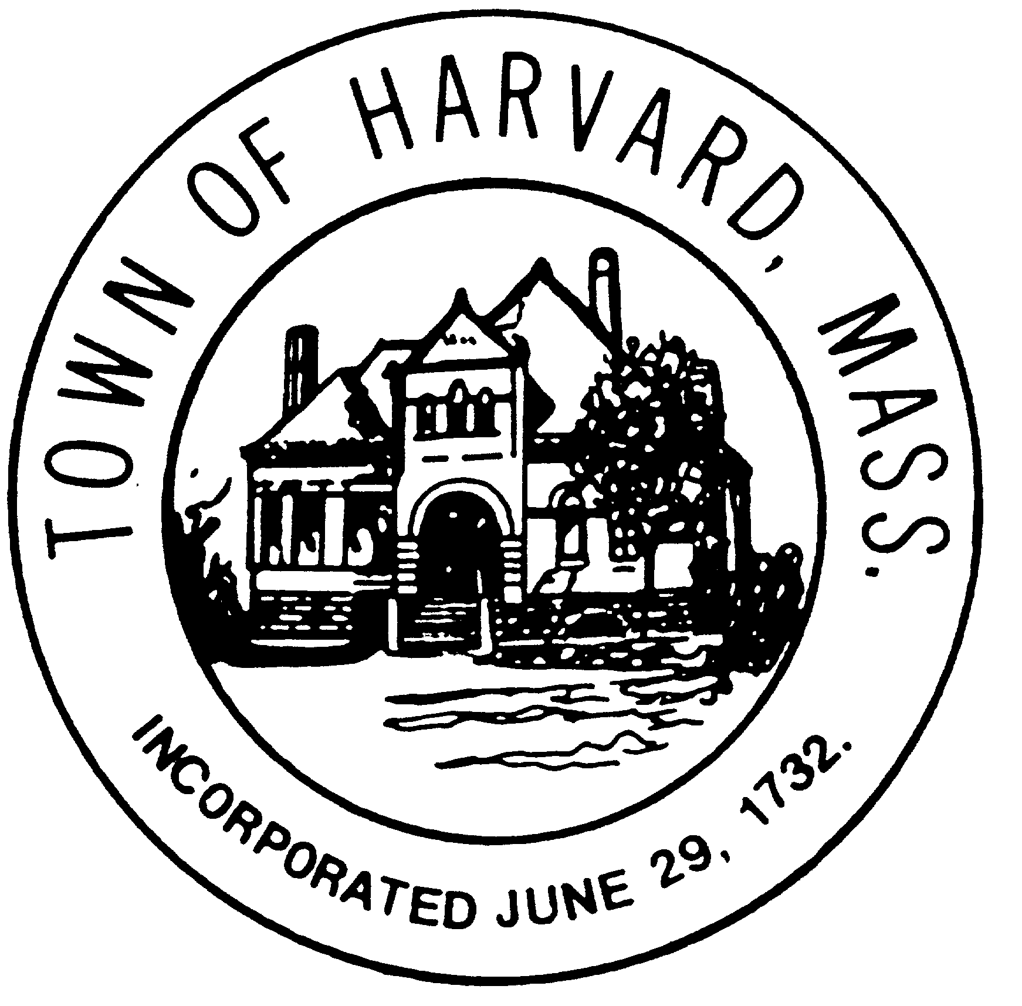
7:30 AM

- Approve Minutes

- Update on Designer negotiations and contract

- Agenda for next meeting

